Instructions for collecting a urine sample
You will be asked to collect a portion of urine periodically when deciding to participate in the Urimon study. This document describes how to collect the urine. Use the provided jar (see image under the heading ‘supplies’) to perform the urine test. This jar is hygienic (does not leak), easy to transport and can be processed automatically at the laboratory.
Supplies:
 | The orange substance in the urine jar is a preservative. It allows the urine to last longer. Do not wash out this orange substance. If you come into contact with it, wash your hands.
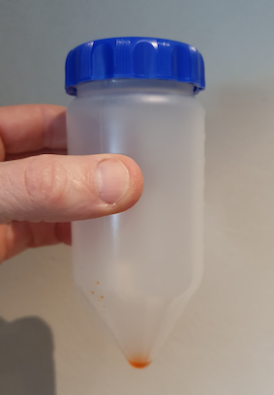
ATTENTION:
- Do not open the jar before use.
- You cannot collect urine during menstruation.
- Make sure you twist the cap tightly on the jar. Be careful, do not stop as soon as you feel resistance, but keep turning until it can not move further.
- Keep the container out of reach of children and pets.
Methodology
1. | 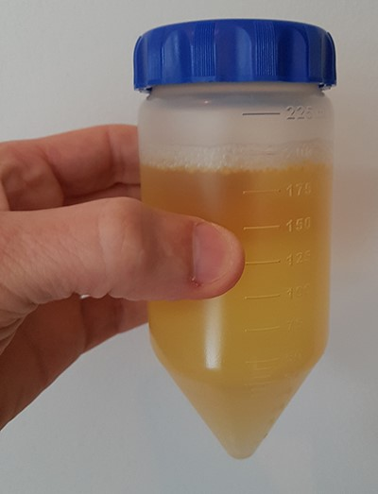  Collect your morning urine on the day you hand the urine in at the blood collection centre or on the day you bring the jar in to return box to a PostNL point.  Morning urine is the urine that has been in the bladder for at least 3 hours and that you urinate the first time you need to go to the toilet when you get up. Let the first bit of urine flow into the toilet and then collect the urine in the jar until it is almost full. In case the jar is not completely full, this is not a problem. You do not have to urinate the pot fuller on a 2nd urination. After urinating, put the lid back on. Tighten the lid firmly. Note, do not stop as soon as you feel resistance, but keep turning until it cannot move further. Flip the jar 5 times so that the urine mixes well with the orange stuff at the bottom.
2. | 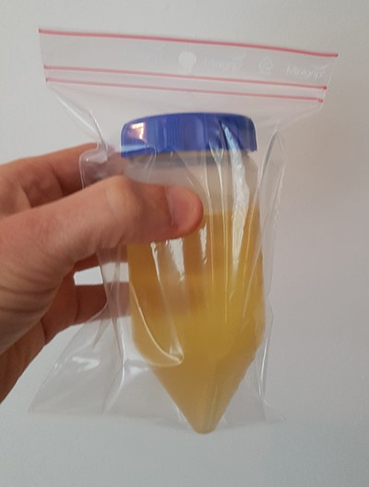  For participants who live near a participating blood collection centre: Place the filled urine jar in the provided bag and close the bag using the sealing strip. Fill in the date and time of the urine collection on the provided urine form.  For those participants who do NOT live near a participating blood collection centre: Write on the sticker the date of urine collection. Place the sticker on the jar. Place the jar in the bag provided and close the bag using the sealing strip.
3. | For participants who live near a participating blood collection centre: Return the bag with the filled jar and completed form to a participating blood collection centre.  For the participants who do NOT live near a participating blood collection centre: Put the jar in the designated return box and deliver the return box free of charge to a PostNL point of your choice.

